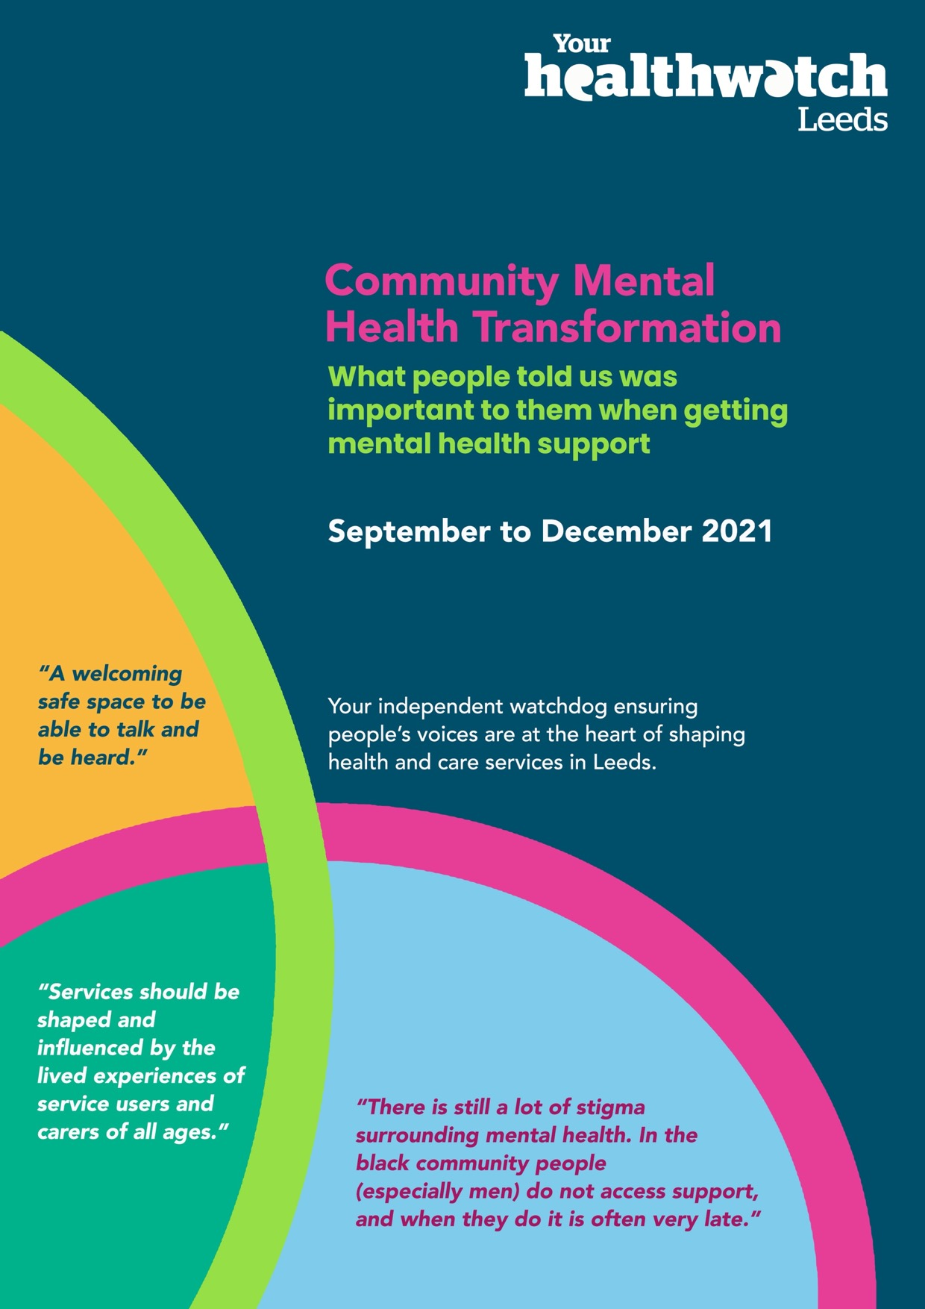

Contents
Summary 3
Key Findings 4
Key recommendations / messages 6
Background 7
Why we did it 8
What we did 9
What we found 10
West Leeds LCP 11
HATCH LCP 16
Leeds Student Medical Practice & The Light LCP 24
Other LCPs 30
Our messages / recommendations 35
Service Provider Response 37
Next Steps 38
Thank you 38
Appendix 1 39
Appendix 2 41
Appendix 3 43
Appendix 4 45
Appendix 5 47
Appendix 6 50
Appendix 7 53
Appendix 8 56

Summary

Introduction
The NHS Long Term Plan set out a new vision for how community mental health services should be delivered. The Community Mental Health Transformation Programme is a partnership of NHS organisations, community and voluntary sector, Adult Social Care and service users and people with lived experience coming together to transform how primary and community mental health services are currently organised and delivered. In Leeds, the new approach is being tried in three Local Care Partnership (LCP) areas, before being rolled out across the city.

The three areas are:
- West Leeds
- HATCH (Harehills, Chapeltown, Burmantofts & Richmond Hill)
- LSMP (Leeds Student Medical Practice) & The Light

A central part of the new approach is that people with lived experience and carers should be involved in deciding how the service is planned and delivered. Healthwatch Leeds were asked to carry out engagement work in the three pilot areas to hear from people who would be using the service and their carers. Their reflections and ideas will be fed into the development of the new model.

We designed a short survey and worked closely with organisations, and community groups in each of the pilot areas to promote the survey. We also attended groups and events in the community to talk to people about the new model of care and get their feedback. We wanted to know what really mattered to people when accessing mental health care and support, and what would encourage them to get involved.

We received 421 responses from people with lived experience, carers and anyone else who wanted to share their thoughts. We received 333 responses from the three pilot areas and 88 from other areas of Leeds.

Key Findings

What is important
We asked people to “tell us up to 3 things that you think are important to consider when we develop and deliver the new service so that people have the best possible experience”.

While there were common themes that emerged across all areas, there were also clear differences. Table 1 is a summary of the key themes and how these were represented in each geographical area. (Please note as people were able to give multiple responses to the question, percentages do not add up to 100).

What people told us was important to them. (Table 1)
Theme | West | HATCH | LSMP & The Light | Other Areas
Access (e.g. location, equality of access, booking methods etc) | 66% | 65% | 76% | 68%
Kindness & Compassion  Being Listened to | 55% | 38% | 53% | 30%
Tailored support | 49% | 66% | 58% | 52%
Culturally appropriate | 3% | 47% | 11% | 23%
Consistent staffing (e.g. key workers and being supported by trusted familiar staff) | 19% | 11% | 7% | 13%
Involvement in care | 9% | 10% | 12% | 13%
Services working together | 31% | 17% | 9% | 16%
Waiting times | 6% | 11% | 26% | 17%
Carer involvement | 3% | 18% | 3% | 8%
Ongoing regular support | 14% | 11% | 14% | 15%
Face to face support | 17% | 7% | 10% | 8%
Group & social activities and support | 15% | 34% | 4% | 36%
Information about support & services | 8% | 21% | 7% | 9%

Getting Involved
We asked people what would encourage them to become an active partner in designing the service. A total of 245 people responded to this question, but it is important to note that 45% of these responses weren’t relevant. Table 2 is a summary of how people’s responses were distributed by area.

Table 2 What people told us was important to them
 | West | LSMP & The Light | HATCH | Other Areas
Accessible to all | 6% | 9% | 22% | 29%
Being Listened to | 12% | 11% | 10% | 14%
Flexible ways to get involved | 41% | 23% | 44% | 23%
A promise of improvement | 35% | 29% | 12% | 17%
Financial support | 6% | 8% | 15% | 11%
Making the system better for myself and others | 12% | 35% | 5% | 6%

Anything Else
We asked people if they had any other comments and received 156 responses across all areas. When we looked at all the responses from across the city, we saw that people most often commented that they would be pleased to see a new approach to mental health being rolled out in Leeds, especially if it is more holistic 22% of all responses touched on this idea. People welcomed the idea of an approach that supports people with all their needs and not just look at their mental health separately from everything else.

However, when we looked at each area individually, specific ideas were more prevalent in certain locations. The issue of accessibility and having simple systems with a range of options for booking appointments was highlighted in LSMP & The Light (27%), as well as in other areas outside the pilot areas (22%).
The need for better education and action to tackle stigma around mental health was mentioned by 17% of respondents from the HATCH area.

Key recommendations / messages
Below is a summary of the key recommendations. The full recommendations can be found on page 35-37 of the report.

Model Development

The new model of care should be available for and accessible to anyone that needs it.

The new approach should be flexible and adapt to people’s needs.

There should be simple and clear information about the service.

Services and systems need to work together better.

The role of carers should be integral to the service.

There should be a key worker-type system for consistency.

Clear and honest communication about waiting times is needed.

People should be involved in their care and, wherever possible, have choices about the support and treatment that they receive.

The new model should ensure that people are always treated with kindness and compassion and feel listened to.

Involvement
- Provide simple, clear information about what is meant by service design and how participants are expected to contribute.
- Set out clear principles and values for the service and be transparent about what can and can’t be promised.
- Use a range of methods to talk to individuals, groups and communities and adapt the approach to suit the audience.
- Go out to people to engage with them and offer incentives.
- Provide feedback to clearly demonstrate impact.
- Keep people informed of progress.

Background

The need for better, more integrated community mental health support was set out in The NHS Long Term Plan published in January 2019. The Community Mental Health Framework for Adults and Older Adults (NHS England) tells us how this will be achieved. The Framework states that,
“People with mental health problems will be supported to live well in their communities, to maximise their individual skills, and to be aware and make use of the resources and assets available to them as they wish. This will help them stay well and enable them to connect with activities that they consider meaningful, which might include work, education and recreation.”

In Leeds, all partners, including service users, carers and people with lived experience, are working together to implement this vision through the Community Mental Health Transformation Programme. The programme is intended to transform how primary and community mental health services are currently organised and delivered for adults and older people with serious mental illness and complex needs.

The aim is to ensure that people can access the right care and support at their earliest point of need, with wide-ranging support closer to home so that people can live as healthy and fulfilling lives as possible in their community.

A key part of the transformation of community mental health services in Leeds will be to set up integrated community mental health hubs aligned to Local Care Partnerships (LCPs). These hubs will bring together services and teams working across primary and community mental health into integrated teams. A range of mental health professionals will work in the hub, including doctors, nurses, social workers and therapists, and there will also be social prescribing and support with housing, employment, debt and substance misuse on site. There will be a single point of access into the hub, multidisciplinary assessment, and access to a wide range of interventions and support. Individuals will be supported by a named key worker to ensure that the care and support is joined up.

The aim is to start small in developing these hubs, and gradually scale up over three years. In year one a Community Mental Health Hub will be piloted in three LCP areas. This will then be rolled out in more areas in year two and by the end of year three there will be integrated Community Mental Health Hubs established across Leeds.

Why we did it
The community mental health transformation programme needs to radically rethink how services are currently organised and delivered. To do that, the diverse voices of service users/patients, people with lived experience and carers must be at the heart of this transformation. These voices are essential and should be embedded in how the new models are designed, delivered and evaluated.

Involvement and co-production need to be central to the new approach. Part of the assurance of the programme includes assessment of how people with lived experience and carers have been involved in the design and delivery of transformed models of care.

This engagement work is an opportunity to hear the voices of local people and involve them in the rollout of the transformation programme in the three pilot LCP areas. The feedback from this work will help shape and inform what the model will look like in each area. It will also highlight gaps where we have not heard from specific groups and communities so that we can address these as the programme is rolled out across the city.

This work provides a further opportunity to begin to address the health inequalities that exist for people using community mental health services – in their access and experience of those services and in their outcomes.

What we did
We developed a short survey (Appendix 1) to find out what people with lived experience, carers and members of the public felt mattered most to them about the new service, both in terms of how they would like to access mental health support, and how they could get involved in developing it. There were three key questions in the survey:
- What matters? – In developing and delivering the new model it is important to understand what really matters to people who will use the service and their carers. We asked respondents to tell us up to 3 things that they felt were important to consider when developing and delivering the new service, in order to ensure that people have the best possible experience.
- Involvement – One of the key themes of the transformation work is that people with lived experience and carers should be fully involved in supporting the planning and delivery of the new model. We asked people what would encourage them to get involved, and how that could be supported.
- Anything Else – At the end of the survey, respondents were given the option of telling us about anything else that they felt was important about the planned new approach to mental health support.

The surveys were distributed in the three pilot LCP areas: Leeds Student Medical Practice and The Light (LSMP & The Light), West Leeds and HATCH, which covers the areas of Chapeltown and Burmantofts, Harehills and Richmond Hill.

We worked with each LCP to adapt our approach so that we could engage effectively with communities in those areas. The surveys were sent out though GP practices, third sector organisations and groups, including those that support carers. We attended mental health hubs and local community groups and events to talk to people and get their feedback. The surveys were also sent out to everyone being supported by the community mental health team in the three pilot LCP areas, along with a freepost envelope for people to return the survey to us.

Several ways to complete the survey were offered, including online, over the telephone, face-to-face (at the hubs, events, and groups) or by post.

What we found

Responses
We received a total of 421 responses to the survey. People were asked to tell us which GP practice they were registered with, and this information allowed us to allocate each response to an LCP. Table 3 shows the breakdown of the responses for each of the three pilot LCP areas. We also received several responses from other areas, which have been grouped together.

We asked people to tell us if they had received or were still receiving support for their mental health; if they were a carer for someone who had; if they fell into both categories; or none of these options. The breakdown of these responses can be seen in Table 3.

Table 3
Name of LCP | West Leeds | LSMP & The Light | HATCH | Other
I receive or have received support for my mental health | 42 | 117 | 66 | 56
I am a carer | 5 | 3 | 15 | 12
I am both | 9 | 3 | 16 | 3
I am neither | 9 | 40 | 8 | 17
Total Number of Responses | 65 | 163 | 105 | 88

This report will look at the responses for each LCP separately in order to identify the key messages and themes from each area. This will also enable us to identify which groups and communities have responded to the survey and where there are gaps.

West Leeds LCP

Background
West Leeds LCP covers a large geographical area including parts of Pudsey, Bramley, Calverley, Rodley, Farsley, Swinnow and Stanningley.

We have used data taken from the Leeds Observatory to understand the make-up of the population in West Leeds. This is based on people who are registered to one of the 7 GP practices within the West Leeds Local Care Partnership area. These practices come within the Leeds Primary Care Network (PCN).

According to data taken from the Leeds Observatory, the population registered to West Leeds GP practices is similar to that of Leeds as a whole, except for lower rates of young adults, and a higher prevalence of White British ethnicity. The proportion of patients from BAME groups in this area is 13%, compared to 29% for Leeds (It is important to note this ethnicity data is only split into BAME and White backgrounds and does not have information on mixed backgrounds.).

Instances of most health conditions are level with, or slightly lower than Leeds as a whole, although rates of obesity and common mental health issues are above comparable figures for Leeds. However, the rate of serious mental health issues is much higher than in other areas with similar deprivation levels.

Out of the total number of recorded patients with a serious mental illness (SMI) in Leeds, just over 8% are in the West LCP. Most of those patients (89%) are from a White background and there are very low numbers (2%) under the age of 25. For a full breakdown of age, gender and ethnicity of people with SMI in West Leeds, see Appendix 2. (Data taken from GP SMI register)

Responses
We had a total of 65 responses to the survey from West Leeds LCP. Below is a visual representation of the responses in percentages.

  - 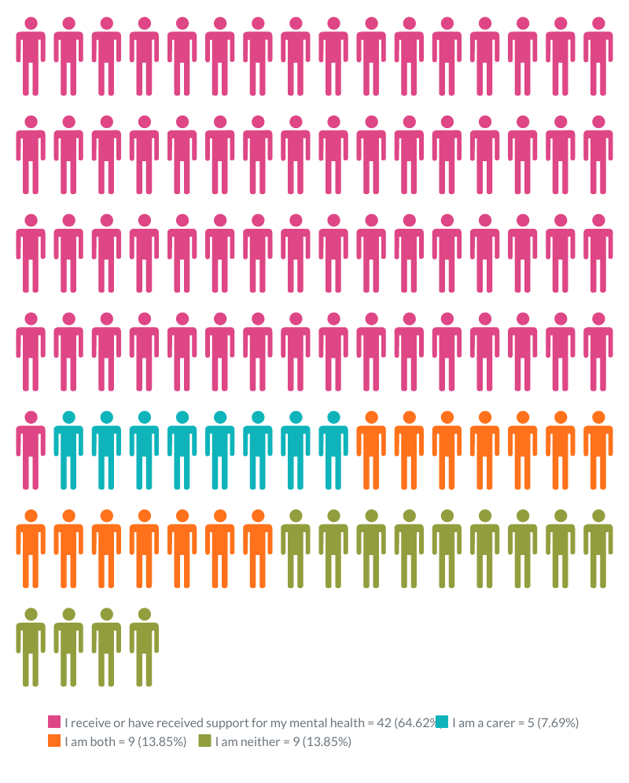
Tables 4, 5 and 6 are a breakdown of the responses we received based on age, gender and ethnicity from those that provided this information. See Appendix 5 for a full breakdown. The response rates are particularly low from BAME groups, which make up only 5% of the total responses. For comparison, 13% of patients in the West come from a BAME background.

Table 4
Age | Number of Responses
18-24 | 2
25-44 | 10
45-64 | 24
65+ | 22
Total | 58

Table 5
Gender | Number of Responses
Male | 22
Female | 38
Total | 60

Table 6
Ethnicity | Number of Responses
White | 57
BAME | 3
Total | 60

Involvement
17 people in West Leeds told us what would encourage them to get involved in designing the new approach. In 41% of cases, people told us that engagement should happen face-to-face, online, in a group setting or one-to-one. We can conclude from this broad range of suggestions that it’s important people in West Leeds are offered a variety of ways to get involved.

35% of people in West Leeds said that having a commitment that their views will be taken into account would encourage them to take part. People wanted to be reassured this would not be “a tick box exercise”, as some said previous engagements had been. In addition to this, 12% of respondents said it was important they felt listened to.

What Matters
People were asked what they felt was important to consider in the new service and were given the option of providing up to three suggestions. 65 people from the West Leeds area responded, providing a total of 164 responses (8 people told us one thing that was important to them, 15 told us two things and 42 people three things).

43 responses (66%) talked about access to services and support being important. Specifically, people referred to the need for services to be based locally and easy to get to, as well as ensuring people’s access needs were met. There was a strong emphasis on people getting the right support when they needed it and having different options to do so. Examples included drop-ins, online support, and services based in GP surgeries.
“Accessibility – face-to-face meetings with disabled access & free parking”
“Home visiting for those unable to get out (anxiety, depression related issues)”
36 responses (55%) highlighted the need for staff to be kind, welcoming, non-judgemental and really listen to the people they support.
“Talk to someone who will listen and believe this is how you feel and understand how hard it is – validate you, non-judgemental”.
“Approachable, understandable and compassionate staff”
32 people (49%) said mental health services and support need to be better tailored to each person’s individual needs and people need to feel involved and listened to. Many of the comments highlighted the importance of having different options and flexibility within the system, so people could have access to support that worked for them.
“Focus on what service users want to do”
“Listen to their problems or feelings, not tell them how to cope”
20 people (31%) talked about the importance of different services working together. Some mentioned that mental health services should be combined with a range of other services to help all aspects of the individual’s life. Respondents felt that, if services worked together, this would lead to better communication, consistency, earlier interventions and support for the individual that met all their needs.
“Housing, benefits, access to a consultant, support with day-to-day living, support and social groups are all important”
“Having everything in one place and all the people actually there that you need to see”
“Consistency of care across various services - each service is not aware of each other’s input into my care”
Some of the other things people highlighted as important included:
- The need for shorter waiting times and having “timely access to the service needed”.
- People receiving a regular service and having consistent and familiar staff. For some people it was important to be able to see the same person each time for them to build up trust and rapport.
- Having a range of options available to give people choice, including face-to-face contact and group therapy and activities.
- The importance of knowing what services are available and how to access them: “Clear signposting to various resources available, empowering people to request the specific help they need”.

Anything Else
11 people in West Leeds shared their other thoughts about the new approach, six of whom said they were pleased a holistic new approach was being designed. Two people also said it would be positive to involve carers and care workers in the service.

HATCH LCP

Background
HATCH LCP covers the areas of Chapeltown and Burmantofts, Harehills and Richmond Hill. Tackling health inequalities is a key priority for the LCP as 39% of HATCH residents live in areas within the 1% most deprived in the country.

We have used data taken from the Leeds Observatory to understand the make-up of the population in HATCH LCP and is based on people who are registered to one of the 15 GP practice within this area. The data is taken from both Chapeltown PCN and Burmantofts Harehills and Richmond Hill PCN as this LCP includes practices from both these PCNs.

According to data from the Leeds Observatory, the Chapeltown PCN registered population is similar to Leeds as a whole, with slightly fewer elderly residents, and far fewer very young adults.

Burmantofts, Harehills and Richmond Hill PCN has a younger than average GP registered population, and in particular a larger proportion of young men.

Most people registered to GPs in these areas reside in the most deprived fifth of the city. The number of people from BAME backgrounds is significantly higher than the figure for Leeds as a whole (29%), at 58% in Chapeltown and 64% in Burmantofts, Harehills and Richmond Hill. (It is important to note this ethnicity data is only split into BAME and White backgrounds and does not have information on mixed backgrounds).

Out of the total number of recorded patients with a serious mental illness (SMI) in Leeds, 16% live in the HATCH LCP. Just over half of those patients (53%) are from a White background, with a large percentage (44%) from BAME backgrounds. For a full breakdown of age, gender and ethnicity of people with SMI in the HATCH LCP, see Appendix 3 (Data taken from GP SMI register).

Responses
We had a total of 105 responses to the survey from HATCH LCP.
Below is a visual representation of the responses in percentages.
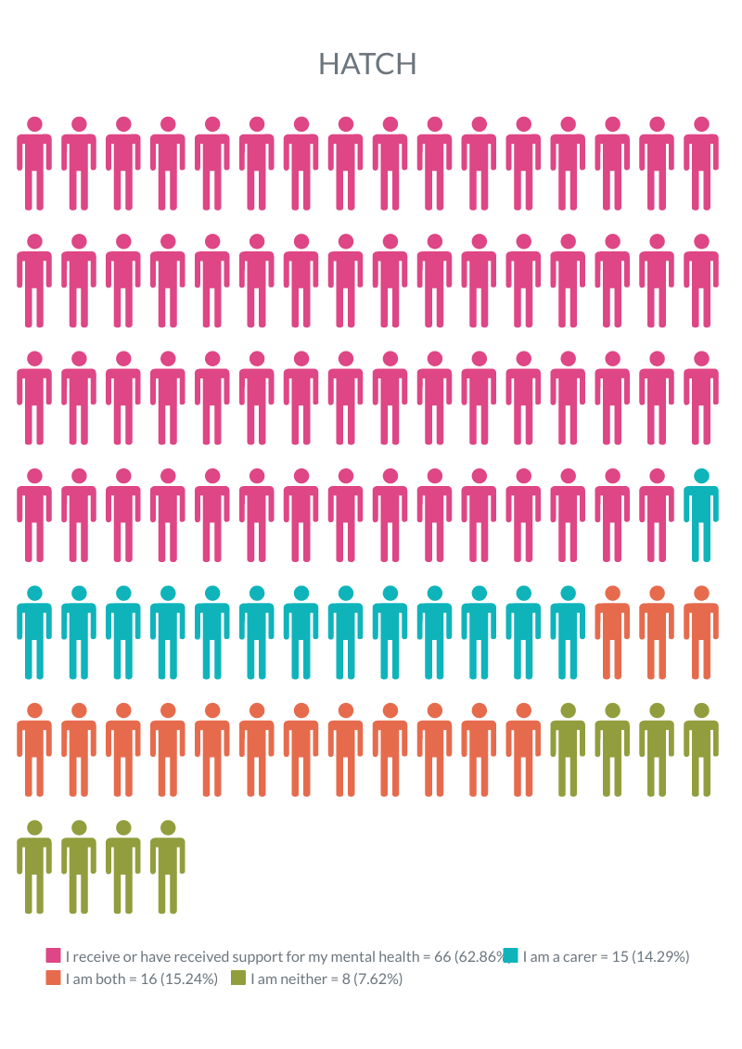
Table 7, 8, and 9 give a breakdown of the responses we received based on age, gender and ethnicity from those that provided this information. See Appendix 6 for a full breakdown. There was a good response from people from BAME backgrounds in this area (58%), which is reflective of the BAME population in the HATCH area (61%)
Table 7
Age | Number of Responses
18-24 | 8
25-44 | 51
45-64 | 30
65+ | 14
Total | 103

Table 8
Ethnicity | Number of Responses
White | 34
BAME | 59
Mixed | 8
Total | 101

Table 9
Gender | Number of Responses
Male | 31
Female | 66
Other | 4
Total | 97

Involvement
41 people from the HATCH area told us what would motivate them to help design the service.
The most common answer related to flexible ways to get involved, a concept which featured in 44% of responses.

22% of people told us that it was important that engagement activities were inclusive and easy to get to. Their ideas included the following:
“Be patient and support people who are unable to leave their homes”
“For me to get involved I would need to take time off during work hours. I would be ok to meet on an evening as my siblings would be at home to look after my mum….”
More people in HATCH than in other areas told us that financial support or incentives such as vouchers or refreshments would be important to them (15%, compared with 6% for West Leeds and 8% for LSMP/The Light).

What Matters?
People were asked what they felt was important to consider in the new service and were given the option of providing up to three suggestions. 105 people from the HATCH area responded to this question, providing a total of 275 responses (11 people told us one thing that was important to them, 18 told us two things and 76 people three things).

68 people (65%) said it was important to make sure mental health services are easily accessible to everyone. This included the need for services to be based locally, but also to be available for everyone. People also talked about the importance of services being accessible to those with different requirements such as hearing impairments or limited English and providing information in a clear format that meets individual needs.
“Local services that I can walk to or have easy access to, so I don’t have to rely on family members”.
“My dad was waiting on the IAPT waiting list for a year and a half. He went to the first and second session but did not continue as he was unable able to understand all the things that were being said. He said the sessions would have been beneficial and could have learnt techniques to overcome common symptoms of anxiety and low mood”.
“Make sure you provide British sign language for deaf people”
69 responses (66%) talked about the need for support to be person-centred and better tailored to everyone’s individual needs. Many of the respondents talked about the importance of listening to people, involving them in their care, and having a flexible approach.
“Adapt activities to the needs of the person”
“Don’t put everyone in the same category – everyone is different and experiencing different mental health needs”
“Know the person, their preferences, and their care and support needs”.
50 respondents (47%) said mental health services need to provide culturally appropriate support for the communities that they serve. People talked about the need for language support and an understanding of different religious and cultural needs.

The issue of stigma and a lack of awareness of mental health support and services within BAME communities was also highlighted. Some people also mentioned it was important to be supported by staff who “look like them” and reflect the communities they are serving.
“There is still a lot of stigma surrounding mental health. In the black community people (especially men) do not access support, and when they do it is often very late”.
“My dad will not miss his prayers but if there is a multi-faith room with washing facilities, I can see him attending”.
“To make me feel welcome I would need to see people that look like me or I can feel comfortable with. I went to …. after my diagnosis & I felt that they communicate with me less or no communication as my English was not so good. I felt out of place in a men’s group with a hijab on”.
36 people (34%) said mental health services should include group activities and therapies. Many of the comments talked about social and educational activities to support isolated people and offer the chance to learn new skills being an important counterpart to mental health support.
“Helping those who don't mix well to develop friendships”
“Space to develop social skills, especially with others who are experiencing mental health issues”
40 respondents (38%) said the staff providing mental health services should be kind, welcoming and non-judgemental and listen to them. Some people also talked about the need for mental health support to be provided in a less formal or clinical space, that felt safe and had a welcoming environment.
“Non-judgemental, caring staff – someone who really listens and someone I can have meaningful conversations with”
“Welcoming safe space to be able to talk & be heard”
22 people (21%) talked about the importance of knowing what services are available and how to access them. Many felt that people were not aware of services and there was a lack of clear information about what support was available. Others felt that having places that could provide information, advice and signposting as well as advocacy support would be helpful. Some also suggested there was a need to work with local communities to raise awareness about mental health and the support available.
“Clear information about what support is available and how we can access it”
“The service to build its trust in the community by promoting their services and raising awareness of Mental Health”
Carers were mentioned by 19 respondents (18%). These responses highlighted the need for mental health services to include carers, both in terms of listening to their opinions and supporting carers themselves.
“Involve carers in care planning and when making any decisions about care. Carers know best, they are the people who look out or after them day in day out”
18 responses (17%) talked about the need for services to work better together. This included suggestions that services be flexible and have staff working across different teams. People also talked about the need to offer a range of treatment options and work with different organisations to provide the best support for the individual.
“Flexible key workers that could overlap & transferable information & feedback with support team”
“Work in partnership with a range of statutory and non-statutory services to offer a wide range of activities and therapies.”
Some of the other things people highlighted as important included:
- The need to reduce waiting times for mental health support and to keep people informed when they are waiting.
- Support to be regular and consistent, so people get the ongoing help that they need, and to have “regular checks on progress” and “someone you can call who knows you for advice”.
- Keeping people informed about and involved in their own care.
- Having a key worker and the same familiar staff team: “Familiar faces make me feel comfortable”. This also helps people build trust in the service and “develop relationship between MH staff & individual”.
- Access to face-to-face contact, for those who want this.
- Services to take on feedback and adapt by “genuinely listening and learning from people who use the services”.

Anything Else
42 people from the HATCH area told us their other thoughts about the service.

24% said they were pleased a holistic new service could come into place, while 17% spoke of the need for public education to counter stigma around mental health:
“Deliver mental health awareness sessions to local community and children so that they understand anyone can experience mental health problems at any time.”
14% said interpreters and support for people speaking English as a second language would be helpful:
“My English is OK, not great, but I cannot always understand the support offer.”

Leeds Student Medical Practice & The Light LCP

Background
Leeds Student Medical Practice & The Light LCP (LSMP & The Light) covers the city centre and university areas of Leeds. This LCP population is made up of people who are registered at these two practices. Students are a key population group covered by this partnership. However, as this area also covers the city centre, it includes groups such as the homeless, refugees & asylum seekers, and the LGBT+ community who are more likely to experience inequalities and challenges around health and care.

Based on figures from the Leeds Observatory, the registered population for this area is dominated by younger adult age groups. The largest age group is 20-29 and the young female population is much higher than the young male population. There is a much larger proportion of BAME patients than in Leeds as a whole (54% compared to 29%). (It is important to note this ethnicity data is only split into BAME and White backgrounds and does not have information on mixed backgrounds).

Out of the total number of recorded patients with a serious mental illness (SMI) in Leeds, 1.5% live in the LSMP & The Light LCP. The majority (74%) are from a White background, with just over a quarter (26%) coming from BAME backgrounds. For a full breakdown of the age, gender and ethnicity of people with SMI in the LSMP & The Light LCP, see Appendix 4 (Data taken from GP SMI register).

Responses
We had a total of 163 responses from LSMP & The Light LCP.
Below is a visual representation of the responses in percentages.

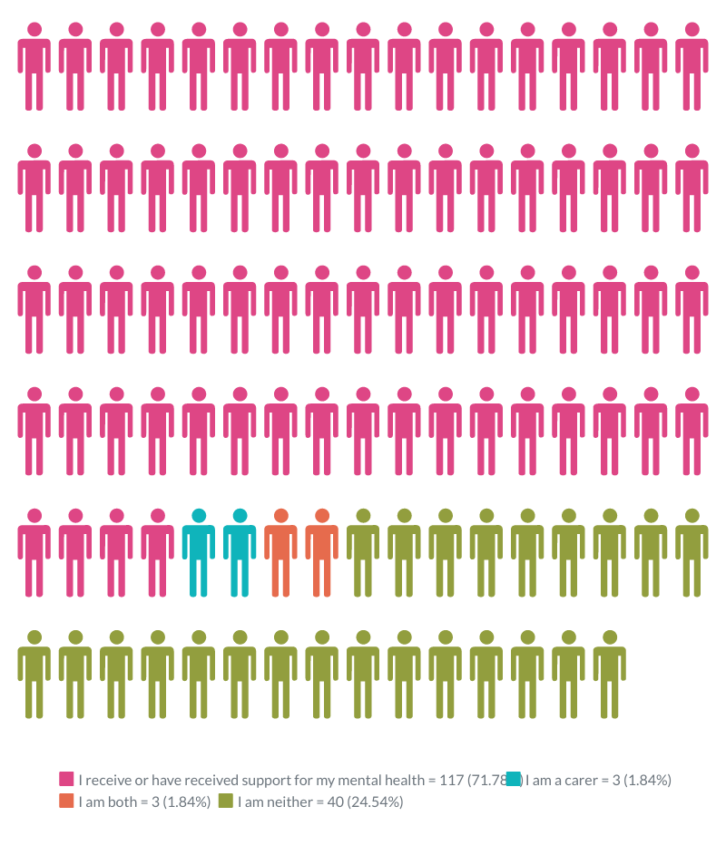

Tables 10, 11 and 12 are a breakdown of the responses we received based on age, gender and ethnicity from those that provided this information. See Appendix 7 for a full breakdown. While there was a significant number of respondents from BAME backgrounds (23%), this is still a lower proportion than we would expect for an area where 54% of people fall into this category. There were an additional 5% of respondents from mixed backgrounds.

Table 10
Age | Number of Responses
18-24 | 121
25-44 | 33
45-64 | 3
Total | 157

Table 11
Ethnicity | Number of Responses
White | 111
BAME | 35
Mixed | 7
Total | 153

Table 12
Gender | Number of Responses
Male | 29
Female | 114
Other | 13
Total | 156

Involvement
75 people registered with LSMP, or The Light told us what would encourage them to help design the new service.

35% said that their desire to help themselves or others get better care is a motivating factor. Sometimes they felt this way because of their previous negative experiences of services. For example, one person said that:
“I would be happy to help, I really care about making these things more accessible to people, especially when it is so easy to be dismissed about mental health”
A small number said they would want to benefit directly from the new service if they were to help design it.

29% said that seeing how things had changed for the better would be important to them, while 23% of responses referred to the need for a flexible variety of ways for people to get involved.

What Matters?
People were asked what they felt was important to consider in the new service and were given the option of providing up to three ideas. 163 people registered with Leeds Student Medical Practice & The Light responded to this question, providing a total of 405 responses (19 people told us one thing that was important to them, 46 told us two things and 98 people three things).

124 respondents (76%) referred to access as being an important factor when providing mental health support. People talked about a range of issues here, including physical access, language support and other needs, and simple and clear booking systems. People also highlighted the importance of having support available out of hours and in different settings such as drop-in and walk-in centres.
“Accessibility and how it can be adapted to each patient, e.g., come to clinics or community centres or offer zoom or phone appointments or home visits or coffee shop meeting”
“Ensuring those most marginalised can access care”
“It needs to be universal - no one should feel like they can’t go there”
94 people (58%) said mental health support should be better tailored to people’s individual needs and there ought to be a flexible approach, with different options available. Some also talked about the need to consider other factors and issues that impact a person’s mental health and to involve people in their care. Earlier interventions to stop people ending up in crisis were also mentioned by some.
“Different types of therapy to suit patients with different needs”
“Being person-centred, recognising that the service needs to be designed around the users and not the other way around”
” More options for low-risk people - this works as a preventative measure so that they are less likely to get to a point of a self- harming or being suicidal and can instead keep their lives on track”
86 of the responses (53%) said people should be treated with respect, kindness and compassion by staff and feel they are being supported in a welcoming and non-judgemental environment.
“Compassion and patience are important; people notice if you don’t really care”
“Safe space to share without judgement”
Staff really listening to their patients was a topic that many mentioned: “I want to be truly listened to.”

42 people (26%) talked about the need for mental health services to respond quickly without long waiting times. Where there are waiting lists, respondents commented that people should be kept informed about how long they would have to wait.
“No long waiting times, sometimes it feels so daunting when the help is so far away”
“Being kept in the loop about waiting times, even if they are long”
Some of the other things people highlighted as important included:
- The need for services to be confidential, discreet and anonymous: “A discrete service so that it isn’t obvious you are accessing mental health services”.
- Having regular and consistent support on an ongoing basis for as long as needed. There should be good follow-up support available to check in on people.
- Mental health services need to better address the cultural needs of different communities and ensure they are accessible to all.
- Better information about what services are available and support to help people find the information that they need.
- People should be kept fully informed and involved in their care: ”Discussing options with patients to make them aware of help available to them”
- The option of face-to-face contact, for those who want this. Services to work better together so people feel supported and listened to:
- “Not being passed around different services - be more than just a signposting system”.

Anything Else
62 people registered with LSMP or The Light shared their other thoughts about the new service with us. 27% said they would like the service to be easier to access than current models, with a lot of answers focusing on making it easier to book GP appointments. For example:
“Getting doctors’ appointments that fill up before 8am is unrealistic for people suffering with mental health issues”
18% said they would be pleased to see a holistic new model come into place, while 16% said they would like to see waiting times for treatment reduced:
“I personally have previously waited on a list for counselling for a year which is far too long.”
A further 16% said treatment and support options should be tailored more appropriately to people’s needs:
“Could work with charities more. I got therapy with SARVLS because it suited me better than the NHS options.”

Other LCPs

Responses
While the focus of this work was on the three pilot LCP areas, we also received responses to the survey from across Leeds. For the purposes of this report, all these responses have been grouped together and the data analysed collectively.
Below is a visual representation of the responses in percentages.

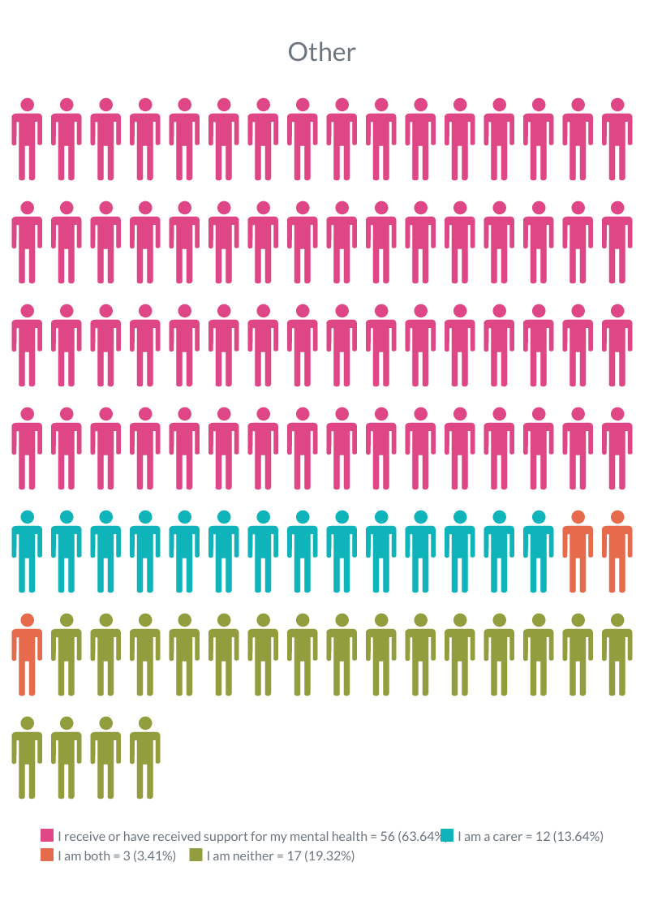

We received 88 responses from areas other than the 3 pilot LCPs.
Table 13,14 and 15 give a breakdown of the responses we received based on age, gender and ethnicity from those that provided this information. See Appendix 8 for a full breakdown.

Table 13
Age | Number of Responses
18-24 | 11
25-44 | 25
45-64 | 36
65+ | 14
Total | 86

Table 14
Ethnicity | Number of Responses
White | 55
BAME | 23
Mixed | 4
Total | 82

Table 15
Gender | Number of Responses
Male | 31
Female | 54
Other
Total | 85

Involvement
35 people who weren’t from one of the three pilot LCPs told us how they could be supported to get involved. Their responses very largely reflected the themes in our three focus areas, albeit in slightly different proportions.

Accessibility was described as important by 29% of respondents, with suggestions including transport provision when engagement activities weren’t local to them.

23% said a flexible variety of ways to get involved was important, while 17% and 14% respectively said a promise of real improvement and a chance to be listened to mattered to them.

What Matters
88 people registered with GPs in other areas of Leeds, or not registered with any GP, responded to this question, providing a total of 225 responses (11 people told us one thing that was important to them, 17 told us two things and 60 people three things).

60 people (68%) said services should be easily accessible to anyone who needs them. Once again people talked about accessibility in terms of physical access and location, but also in terms of availability of services, ease of getting in contact and the support offered to those with access requirements. Some people mentioned a possible drop-in centre or a self-referral system so they could access the services they need without being placed on a long waiting list.
“Ensure services are local and easily accessible”
“Proper telephone number - answer straight away”
“Make accessible for all cultures/languages”
46 respondents (52%) mentioned the importance of mental health support and treatments being tailored to individual needs. People talked about services being flexible and adaptable and providing a range of options, so everyone could find something that worked for them. The range of comments about what people felt was helpful demonstrates the need for choice in the support people get and the way it is delivered.
“Always involve us in the planning and delivery of care”
“Services should be shaped and influenced by the lived experience of service users and carers of all ages”
32 people (36%) suggested group therapies and activities were important. Comments referred to the need to have spaces for social groups and activities, as well as people being offered group therapy and support groups.
“Provide groups relevant to post-natal depression or other diagnoses so people feel comfortable”
“Provide group peer sessions”
26 respondents (30%) said staff should be kind, welcoming and non-judgemental and people should be treated with respect. Respondents talked about the importance of having safe spaces where they felt supported and listened to.
“Be sensitive and respect our mental health conditions”
“Safe place where drop-in’s can happen”
Some of the other things people highlighted as important included:
- Waiting times for support need to be shorter: ”current services are not quick or responsive enough”
- The need to “have an understanding of the culture and faith background of the service user.”
- Services to work together better so that there is consistency and people can get support with all their needs. Have a “holistic approach for patients with mental health problems”.
- The importance of having regular ongoing support and staff who were familiar and consistent. People stressed the need for continuity with staff to develop better trust.
- Having the option of face-to-face contact for people who wanted this.
- Providing clear information about the services and support on offer.
- Keeping people fully informed and involved in their care: “Important that people involve me in decisions and explain why things are happening/changing”.

Anything Else
41 people who weren’t registered in one of the three pilot LCP areas shared their other thoughts about the proposed new service.
22% said it was important that they could access support somewhere which was appealing and easy to reach:
“Sometimes we just need a place to go sit down and have nice people speak to you. It shouldn't be too clinical rather more informal.”
20% said treatment and support should be tailored more appropriately to people’s needs:
“More information on medication - some people are reluctant to take medication. Need talking therapies”

Our messages / recommendations
This report sets out clear messages from people in each of the three pilot LCP areas as to what is important to them when receiving support for mental health. While consistent themes came out across all areas, such as good access and support tailored to individual needs, it is important to recognise that there were some clear variations across each area.

Each of the three areas look very different in terms of their registered populations, levels of deprivation and health inequalities. This is reflected in the feedback from people about what is important to them. One example of this is where almost half of the respondents from HATCH talked about the importance of cultural needs being considered, compared to the West where this was only mentioned by 3% of respondents.

Other factors such as the involvement of carers is rated important by more people in HATCH than in the other areas. More people from LSMP & The Light talked about the importance of services being accessible than in any of the other areas.

Waiting times are also mentioned by higher numbers of people from LSMP & The Light (26%). While this issue was highlighted in all areas, the proportion of people who referred to it elsewhere was lower.

Recommendations – Model Development
Based on the feedback received, we would make the following recommendations:

- The new model of care should be available for and accessible to anyone that needs it. This should take account of location of services, language and other access needs and how people make contact with services and access support.
- The new approach/model should be able to adapt and be flexible enough to meet the needs of different communities and individuals.
- There should be simple and clear information about the service, who can get support (and who cannot) and how it can be accessed.
- Services and systems need to work together and talk to each other so people can get support for all their needs.
- The role of carers should be an integral part of the service, and they should be fully involved and supported.
- There should be a key worker type system in place to ensure people have consistency, both in their care and the staff that support them.
- Clear and honest communication about waiting times is needed and regular check-ins should take place with people on waiting lists.
- People should be involved in their care and care planning, and wherever possible, have choices about how that support is given; options should include, for example, face-to-face support, group sessions and remote appointments.
- The new model should ensure that people are always treated with kindness and compassion and feel listened to. These principles should underpin the model design and delivery and processes should be put in place to monitor that this is happening across all areas.

Recommendations – Involvement
It is important to highlight that when people were asked what would encourage them to get involved, almost half of the responses received were not relevant to the question. In most cases, people said what they would like the new service to be, rather than explaining how they could be supported to get involved in its design. We can draw two conclusions from this:
- This cohort of respondents has a clear understanding of what it means to offer suggestions that will improve a service but is less familiar with what it means to be an active participant in service design.
- This cohort is willing to get involved only if they are confident in advance that the service will adhere to their needs and hopes.

If there is to be a genuine commitment to involving people in the development of this new approach and co-produce the model, we would make the following suggestions/recommendations:
- Provide simple, clear information about what is meant by service design and how participants are expected to contribute.
- Set out from the very start the kinds of principles and values the service will adhere to, but also be transparent about what can and can’t be promised.
- Use a range of methods to engage with individuals, groups and communities and adapt the approach to suit the intended audience.
- Go out to people to engage with them (rather than expecting them to come to you), and offer incentives so people feel valued for their time and contribution.
- Provide feedback to clearly demonstrate the impact that involvement has had and the difference this has made
- Keep people informed of progress (even when there are delays), so they feel an equal partner in the process.

Service Provider Response
As a partnership, we are committed to involving people in the design, delivery and ongoing improvement of mental health services across Leeds. We are grateful to everyone who took the time to share their views. This report will be used to shape the design of the new model as it is tested out in the three pilot LCPs. We will feed back on how the recommendations from this report have been used to inform the new model of care.

We have a dedicated Involvement Lead and a growing network of people with lived experience (including carers) supporting this work. We welcome the feedback and suggestions in this report on what we need to do to help and support more people to get involved, and for that involvement to be meaningful. This report will be shared with that network, so that it informs our ongoing approach to working with people across Leeds. Liz Hindmarsh - Programme Manager Transforming Community Mental Health

Next Steps
The report will be shared with the Community Mental Health Transformation Programme Board and model development working group. The report will also be shared with the three pilot LCPs and all partners involved in the transformation programme.

We will seek assurance that the messages from this report and our recommendations will be fed into the model development work and request information on how this will happen.

We will follow up on any actions to ensure the feedback from this report has influenced development of the new service.

The report will also be published on the Healthwatch Leeds website. https://healthwatchleeds.co.uk

Thank you
This report has been written by Sharanjit Boughan, Project Worker at Healthwatch Leeds in collaboration with Anna Chippindale (Project Worker) and Beth Atkin (Volunteer). Thank you to our volunteer Michael Shaw for helping to analyse the data.

We would like to thank all our partners from the pilot LCPs for helping to distribute and share the survey in their areas and especially to those that supported our engagement work with local groups.

Finally - and most importantly - we would like to thank all the people that took the time to complete the survey and those that welcomed us to their groups and shared their views with us.

Appendix 1

Survey

  - The community mental health transformation programme is a new way of supporting adults with ongoing complex mental health needs. The plan is for all services to work together, so that people can get the support they need, when they need it. The new approach will provide mental health support at a local level, with help and advice for other issues such as housing, employment and physical health all in the same place
  - In Leeds we are going to start by trying out the new approach in three areas of the city. We will be designing and testing new types of care and support in partnership with people who currently use services and who have lived experience of complex mental health needs, and carers.
  - We want to hear from people in Leeds about what is important to them as we plan the new model, so that we can make sure people are given a say in what this should look like.
  - Please could you take a few minutes to answer some quick questions and share your experience or thoughts with us. This information will be anonymous and will be used to help us to design and deliver the new model of care. Thank you for your time.

About You
  - 1. Which of the following best describes you? (Please select more than one option if needed
- I currently receive support for my mental health or have received support in the past
- I am a carer for someone who is currently receiving support for their mental health or has received support in the past
- Both of the above
- None of the above

What is important to you
  - 2. We want to work closely with people with lived experience and carers to develop and deliver the new service. What (if anything) would encourage you to help us design this new approach to mental health support?
  - 3. Please tell us up to 3 things that you think are important to consider when we develop and deliver the new service so that people have the best possible experience. (You do not have to tell us 3 If you can only think of 1 or 2 things)
4 Is there anything else you would like to say about this planned new approach to mental health support?

5. Please tell us the name of your GP Practice. (This information will help us make sure we are speaking to people from different areas in the city and will not be used to identify you)

Monitoring Information
Please can you fill in your details in this section, or if you are completing it on behalf of someone then fill in their details. Completing this section is optional.
By filling in this equality monitoring section you will help us ensure that we get feedback from all our communities. This information will not be used to identify you, but it is very useful to help us better understand the experiences of people from different communities.

6. How would you describe your ethnic group?
7. Do you consider that you have a disability?
Yes No

8. What is your gender?

9. What is your sexual orientation?

10. Which age group do you belong to?

Appendix 2

SMI Patients Recorded – West Leeds LCP
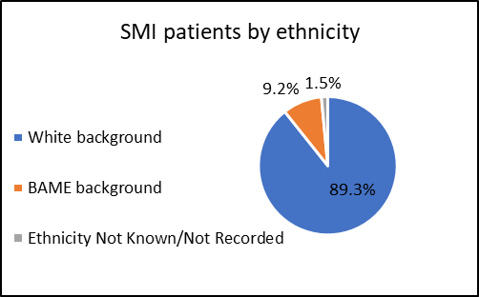

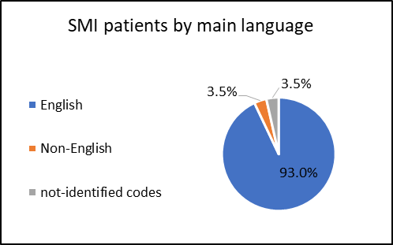

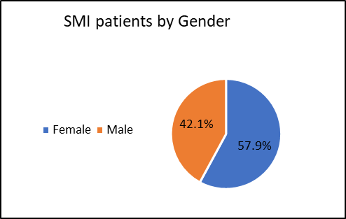

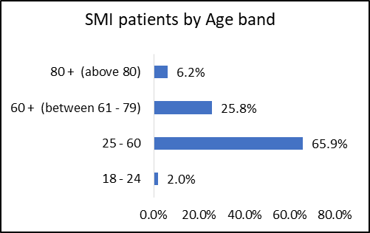

Appendix 3

SMI Patients Recorded – HATCH LCP

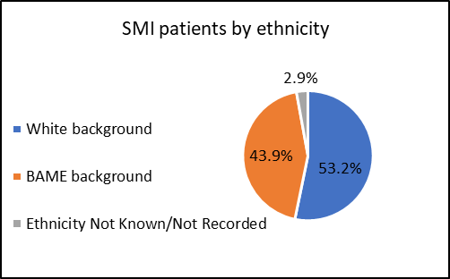

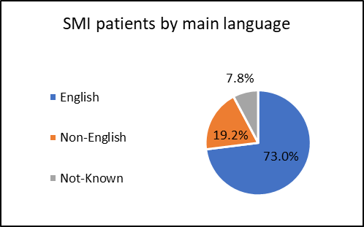

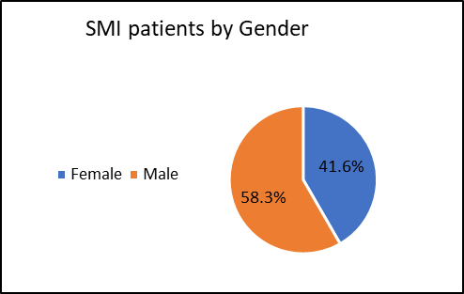

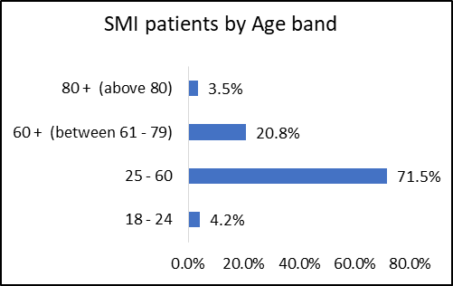

Appendix 4

SMI Patients Recorded – LSMP & The Light LCP
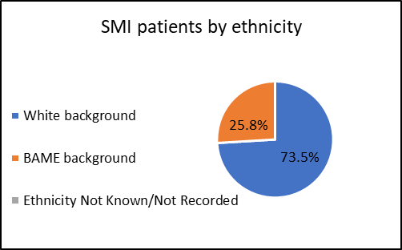

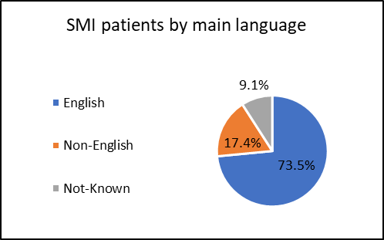
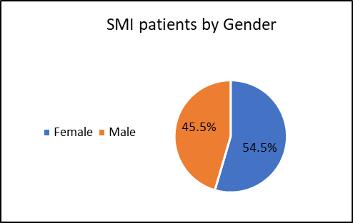

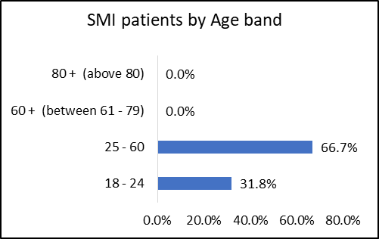

Appendix 5

Monitoring Information – West Leeds LCP
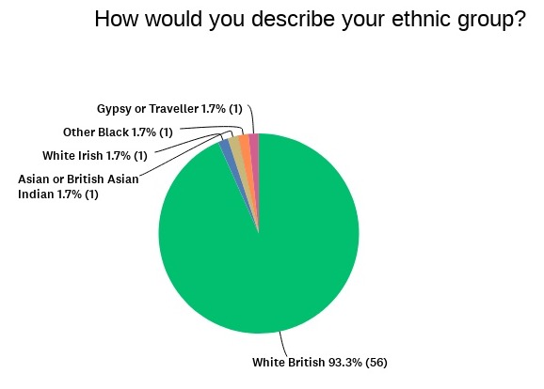

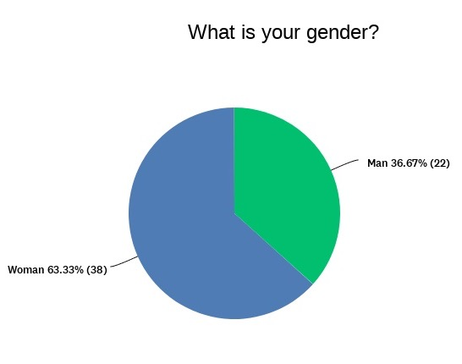

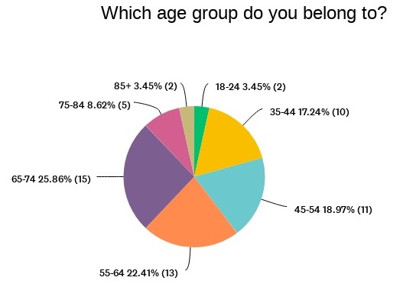

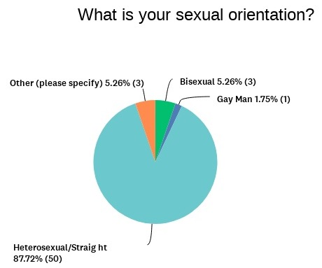

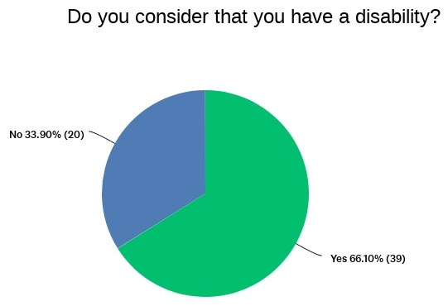

Appendix 6

Monitoring Information – HATCH LCP
  - 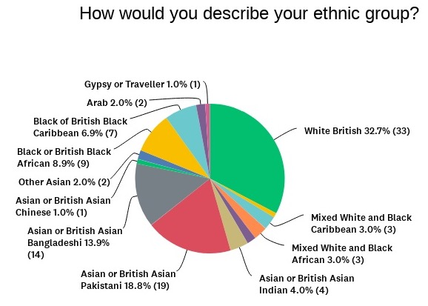
  - 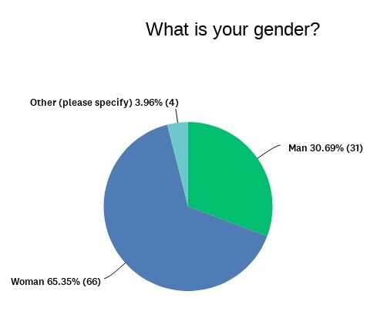

  - 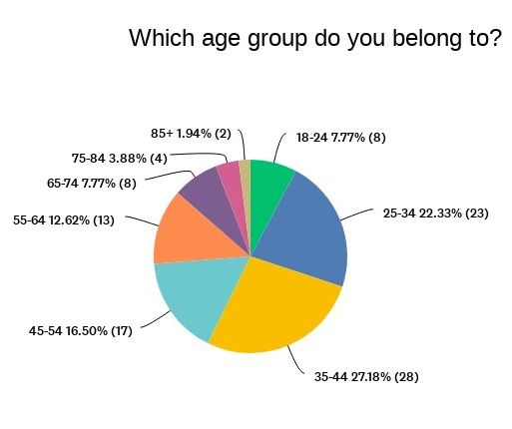

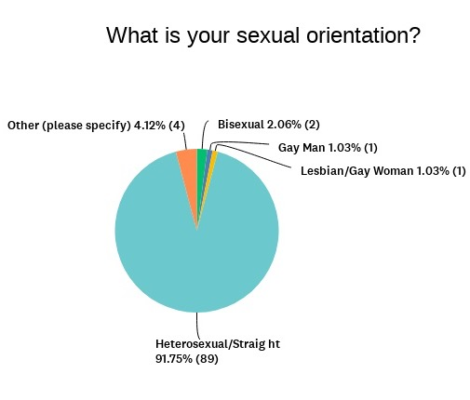
  - 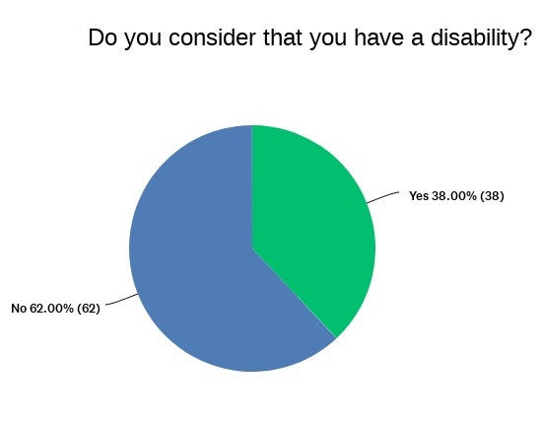

Appendix 7

Monitoring Information – LSMP & The Light LCP

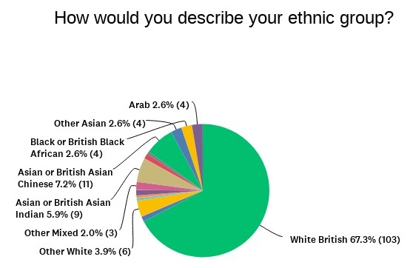

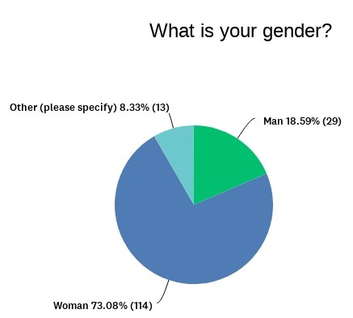

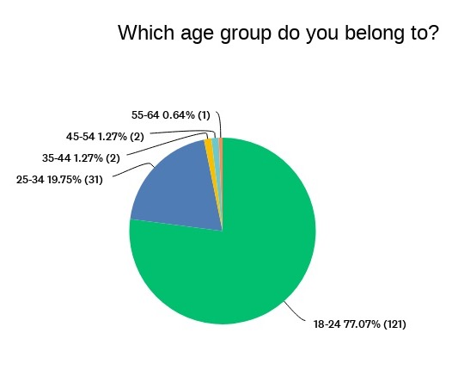

  - 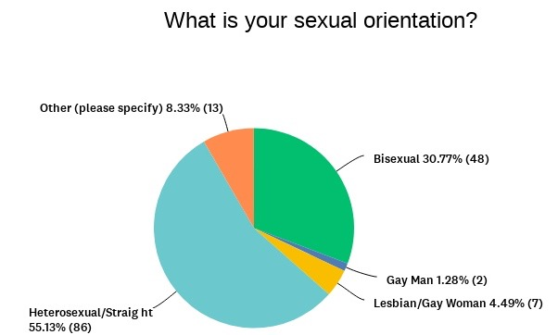
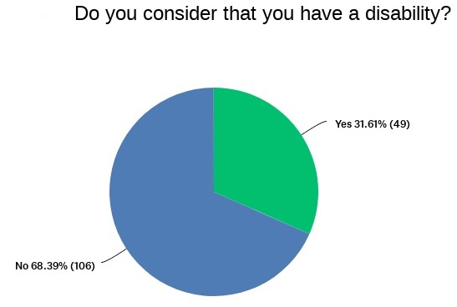

Appendix 8

Monitoring Information – Other LCPs

  - 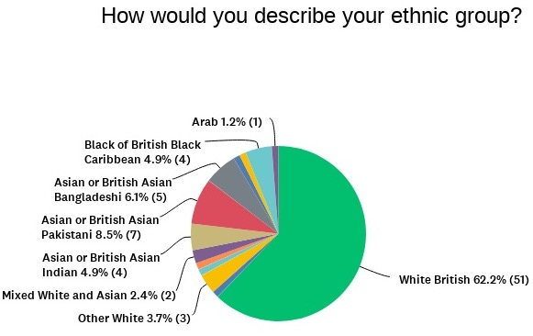

  - 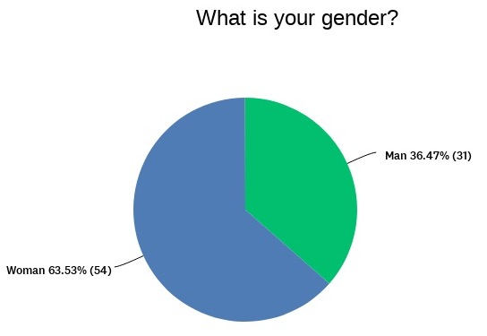

  - 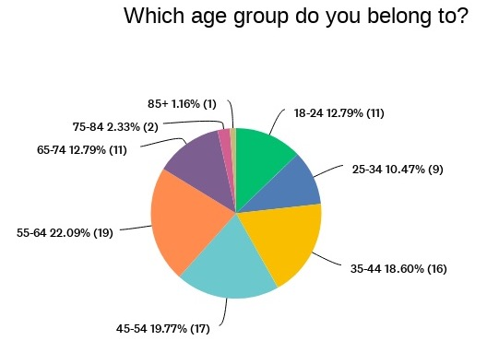

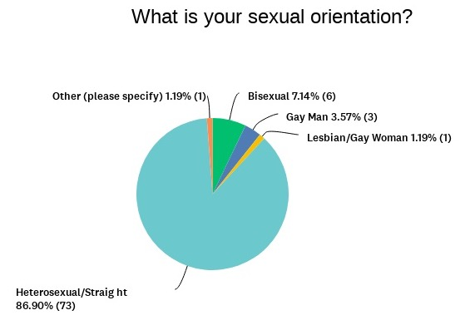

  - 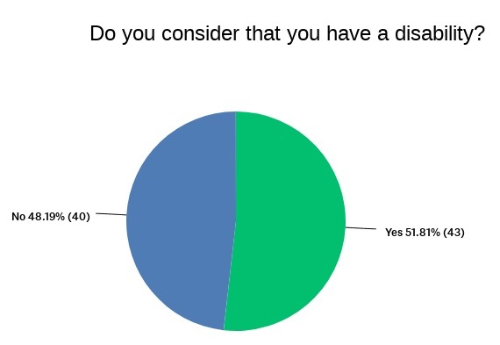

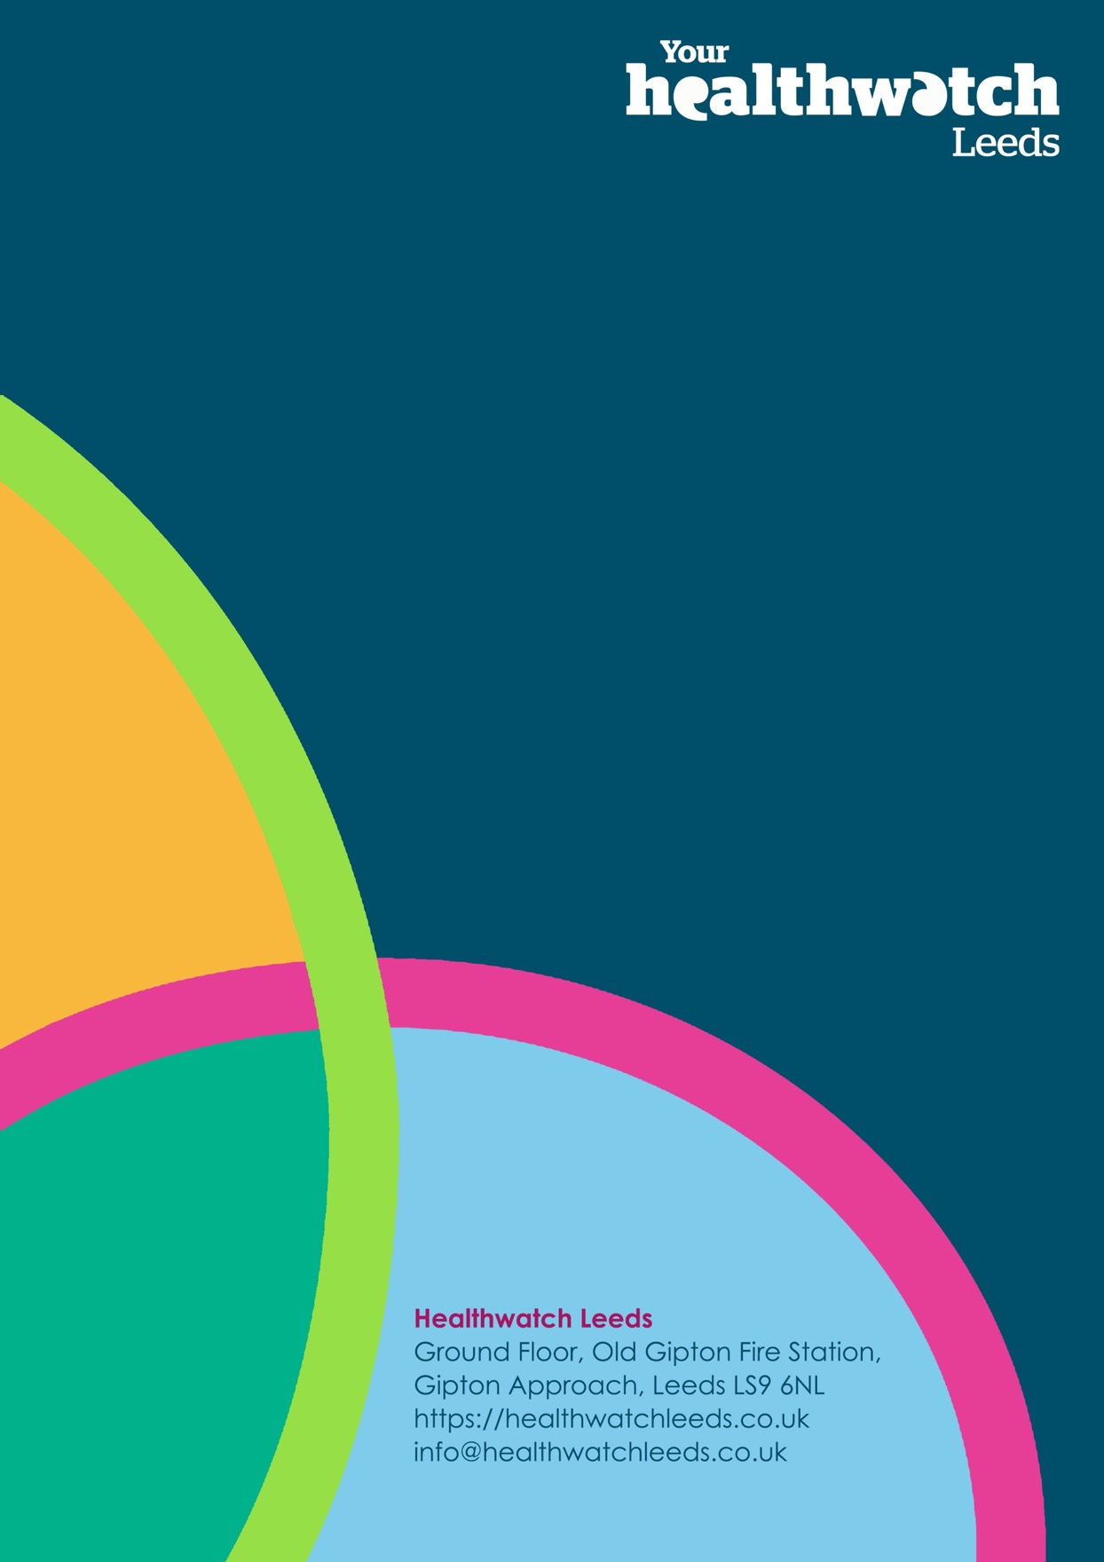

Local Care Partnerships (LCPs) is the term used in Leeds to describe the model of joined-up working to deliver local care for local people; working in and with local communities.
In Leeds each Local Care Partnership is built from a Primary Care Network alignment, which is based upon GP Practices. Some PCNs meet as LCPs but others like Chapeltown have joined up with Burmantofts, Harehills and Richmond Hill and they come together to meet as HATCH Local Care Partnership

